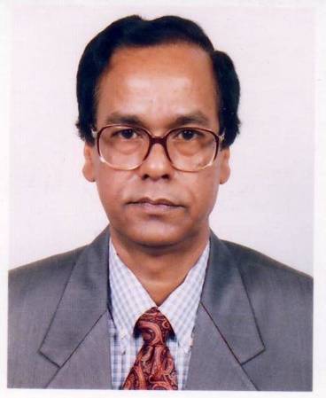
S. R. Howlader, Ph. D.
Professor, Institute of Health Economics, University of Dhaka

Tel +88 (2) 9661920-73, Ext. 8641 (Office), Fax: 88-02-8615583
Email : srh.ihedu@gmail.com
Web site :www.ihe.ac.bd

Dr. Sushil Ranjan Howlader is a Professor of the Department of Economics (on leave) and currently of the Institute of Health Economics, University of Dhaka, Dhaka. He was the founder Director of the Institute of Health Economics of University of Dhaka and worked in that capacity from 1998 to 2005 and again from 2007 to 2010 (July). He is also the former Director of the Bureau of Economic Research, University of Dhaka.

Dr. Howlader obtained his B. A. (Hons.) and M. A. degrees in Economics in 1971 and 1972, respectively, from the University of Dhaka. He has carried out his doctoral study as a Winrock scholar on Development Economics at Jawaharlal Nehru University, New Delhi, in 1993.
Dr. Howlader has considerable experience in social science research. He is the author or co-author of several books, a number of monographs and research reports, numerous articles in journals and chapters in edited books, and a good number of seminar papers. Another book is going to be published shortly.
Teaching areas:
- Health Economics
- Microeconomics
- Economics of Health, Population and Nutrition
- Macroeconomics
- Reseacrch Methodology

Research Areas:
- Health Economics
- Economic Evaluation of Health Care
- Impact evaluation of the social programs
- Insurance Economics
- Pharmacoeconomics
- Food safety
- Social security

MPhill and PhD Supervision:
Dr. S.R. Howladerhas supervised several PhD and MPhil students with topics that are in line with the research interests described here. Currently supervising three Mphil students and three PhD Students. Was Also an external examiner of Ph.D. Thesis of several candidates of Jadavpur University, India, and Andhra University, India
Selected Publications:
- S. R. Howlader and M. U. Ahmed, (1999). Export-Led Growth Strategy for South Asia: Issues", in Export-Led Growth Strategy for South Asia, to be published by APDC, Kuala Lumpur, Malaysia (with M.U. Ahmed).
- S. R. Howlader (1999). Partiality and Predisposition of Modern Approaches to Rural Development : An Appraisal, Social Science Review
- S. R. Howlader (1996). Involution and Stagnation in the Bangladesh Economy, Journal of the Bangladesh Asiatic Society, January
- S. R. Howlader and H. R. Khan (1990). A Note on the Income Velocity of Circulation of Money in Bangladesh". The Bangla,esh Development Studies, Vol. XVIII, No.1, Dhaka

Selected Researches:
- Level and Determinants of Unofficial Fees at Health Care Facilities in Bangladesh: A Study of Selected Facilities, Research Report No. 6, IHE, DU. (Co-author), 2002
- Prevalence and Economic Impact of Tobacco Consumption in Bangladesh: A Household Survey in Selected Rural and Urban Areas, Research Report No. 7, IHE, DU. (principal author), 2003
- Containing Population Pressure for Accelerating Poverty Reduction in Bangladesh, Paper 25, Centre for Policy Dialogue, Dhaka, 2002
- Private HNP Sector Assessment: Findings on Surveys on Private Providers and Consumers, Research Report No. 9, IHE, DU. (principal author), 2002
- Derivation of Demand Function for Healthcare, Method of Assessment of Demand and Formulation of Strategies for Healthcare Financing in the Context of Rural Bangladesh, Working Paper 6, IHE, DU., 2005
- Measurement of Monetary Value of Economic and Non-economic Effects of a Disease: A Consumer-Theoretic Approach, Working Paper 5, IHE, DU., 2005
- Study to Identify Ways to Increase Postnatal Coverage, Research Report for National Institute of Population Research and Training, June (Co-author), 2007
- Family Planning Market and Evidence on Willingness and Ability to Pay, Research Report for National Institute of Population Research and Training, December ( Co-author), 2007
- Study on Youth and Adolescents, Research Report Prepared for National Institute of Population, Research and Training, December ( Co-author), 2010
- “Effects of Implementing UNICEF- Supported Local Level Planning for Improvement of MNCH Services in Bangladesh: Baseline Assessment in Selected Upazilas” Sponsored by UNICEF, Dhaka, March 2015 (Acted as one of the Co-Principle Investigators)
- “Analysis of Investment Case Analysis for the Rural Areas of Chittagong and for Rural and Urban Areas of Sylhet District using Marginal Budgeting for Bottleneck (MBB) Tool” Sponsored by UNICEF, Dhaka. November 2015 (Acted as one of Co-Principal Investigator)
- “Use of Pooled Fund for Improvement of Maternal, Neonatal and Child Health (MNCH) Care in Bangladesh” Sponsored by UNICEF, Dhaka, February 2016 (Acted as one of Co-Principal Investigator)

